**Data Visualization of Bird Strikes between 2000 – 2011**

Wireframe Documentation

**Final Dashboard**

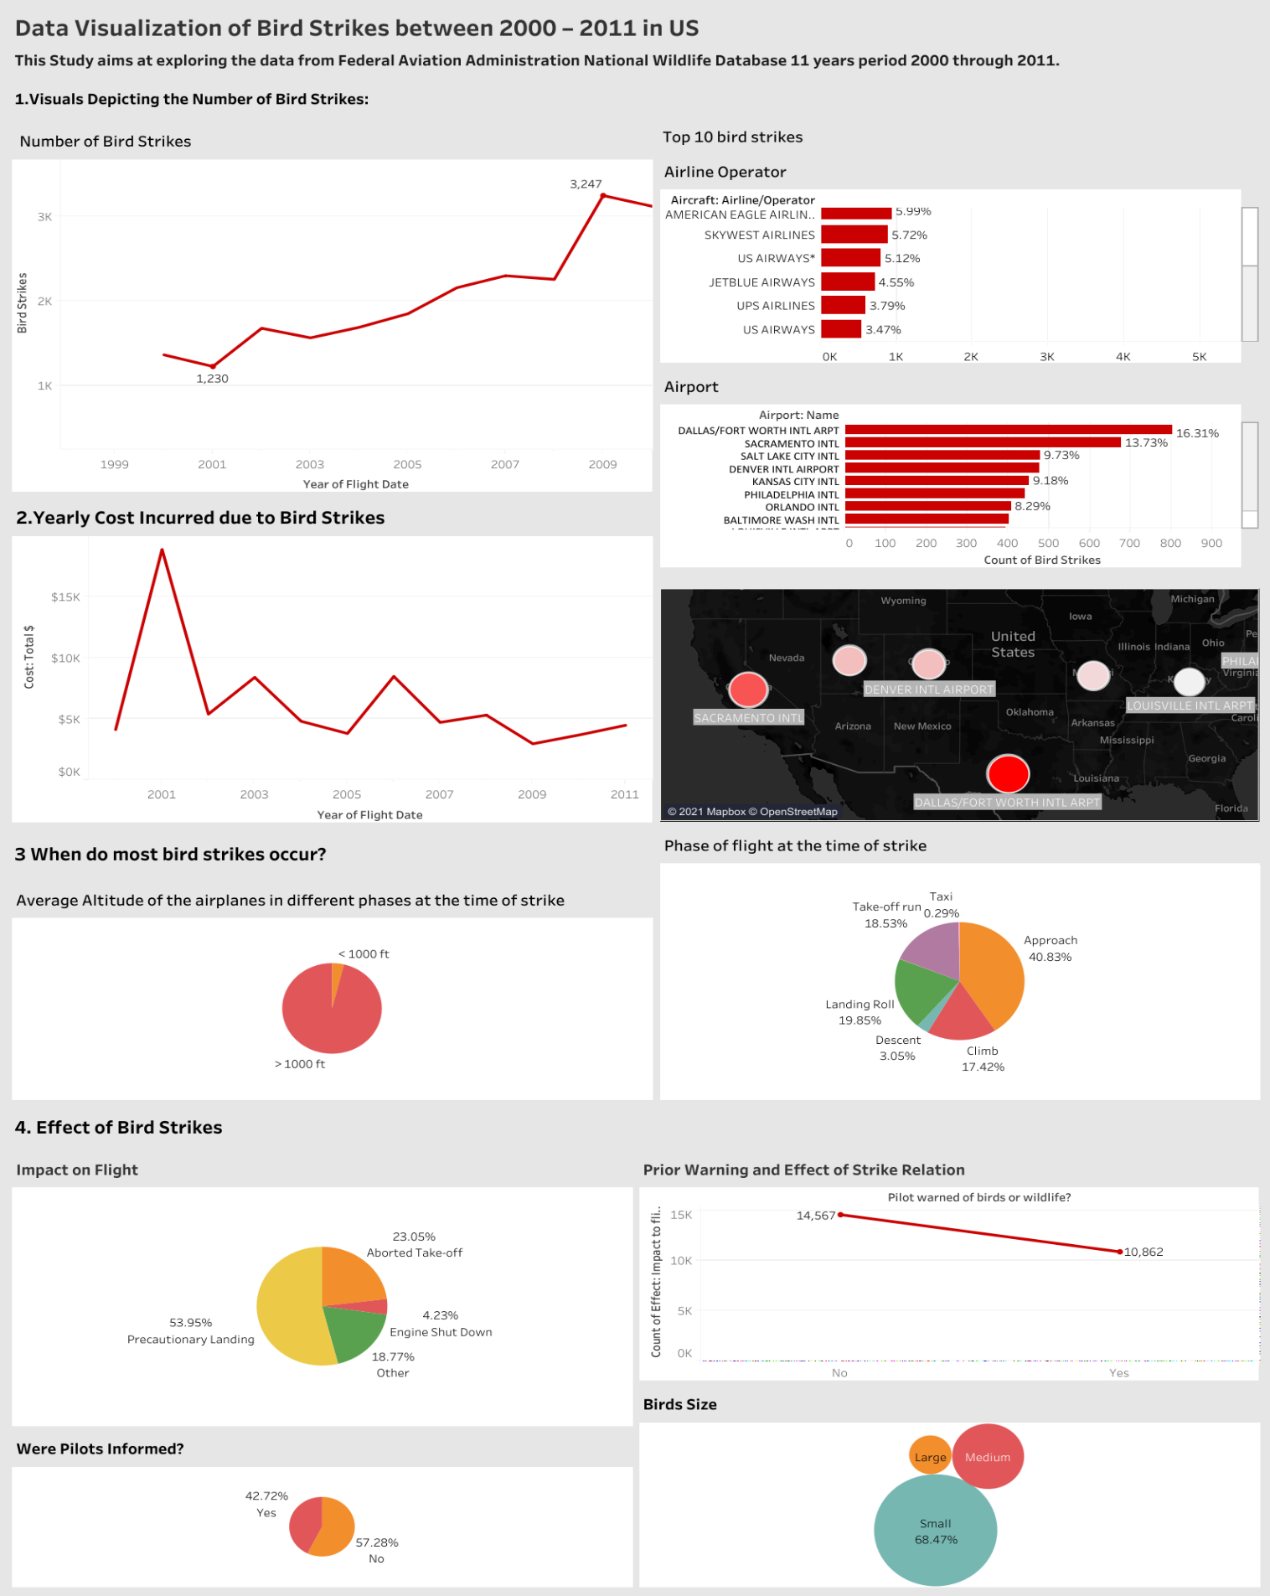

1. Visuals Depicting the Number of Bird Strikes:

1.1 Bird Strikes in US

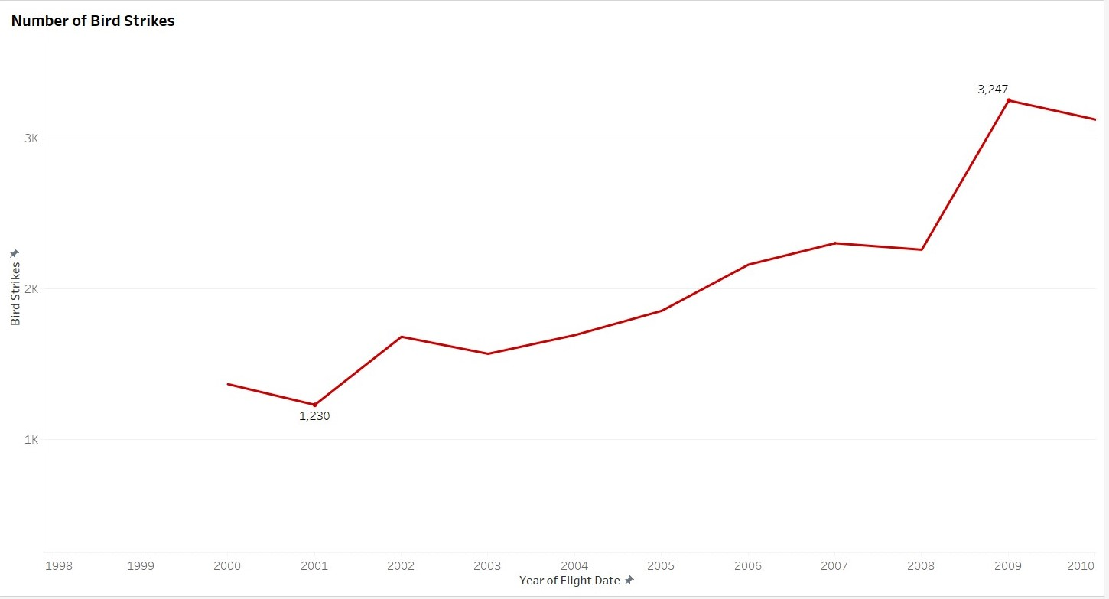

1.2. Top 10 US Airlines in terms of having encountered bird strikes

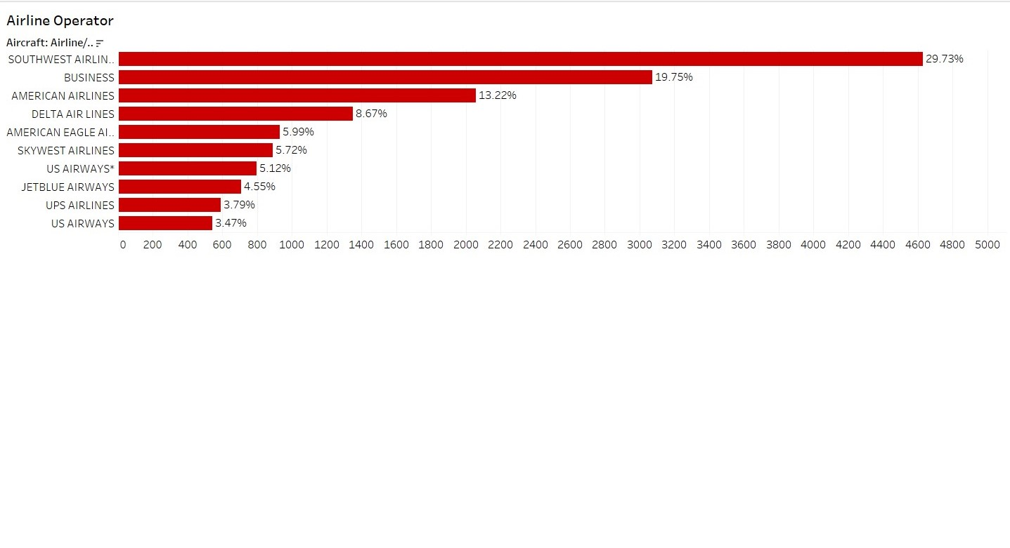

1.3. Top 10 Airports with most incidents of bird strikes

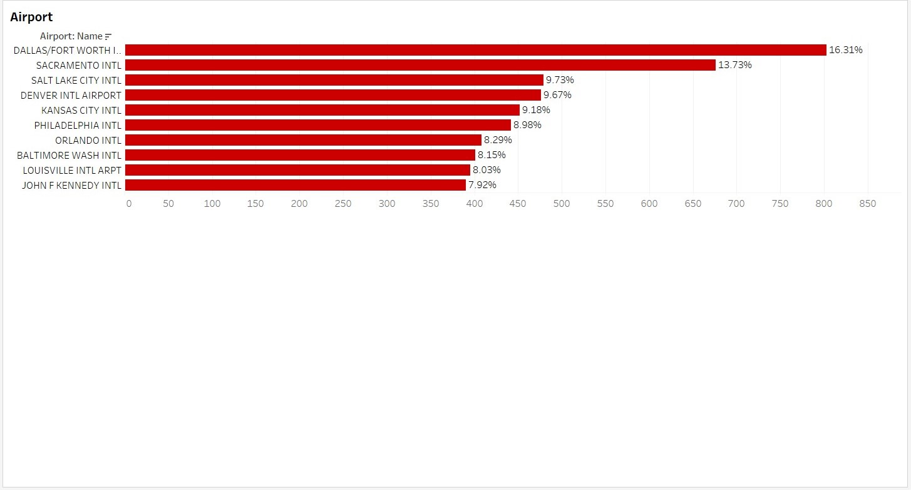

2. Yearly Cost Incurred due to Bird Strikes:

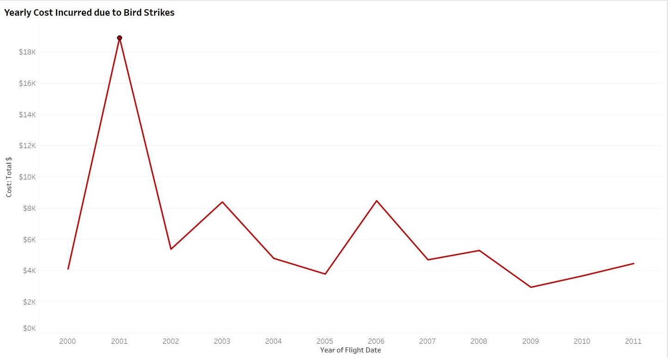

3. When do most bird strikes occur?

3.1. Average Altitude of the airplanes in different phases at the time of strike

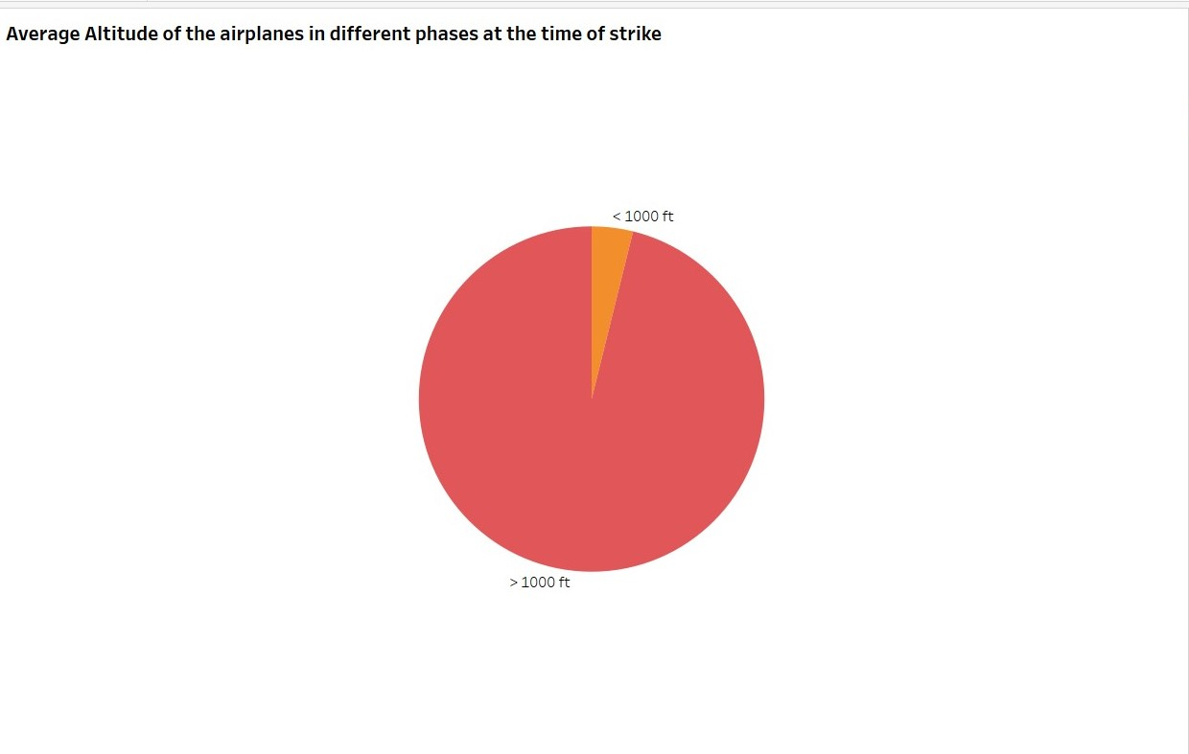

3.2. Phase of flight at the time of strike

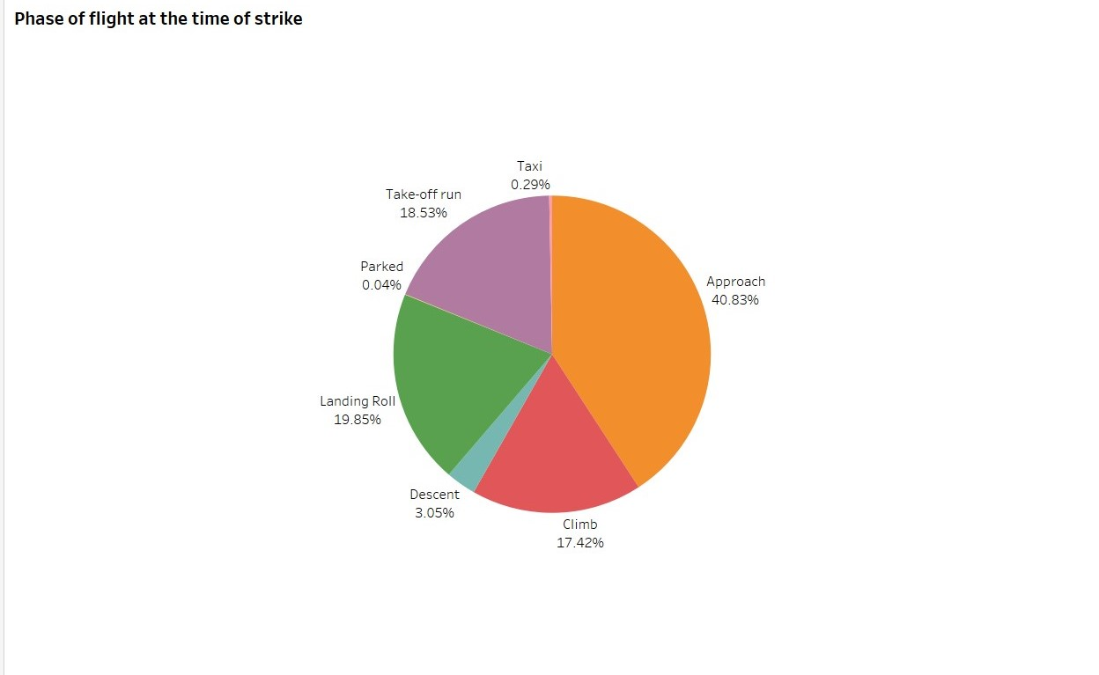

4. Effect of Bird Strikes

4.1. Were Pilots Informed?

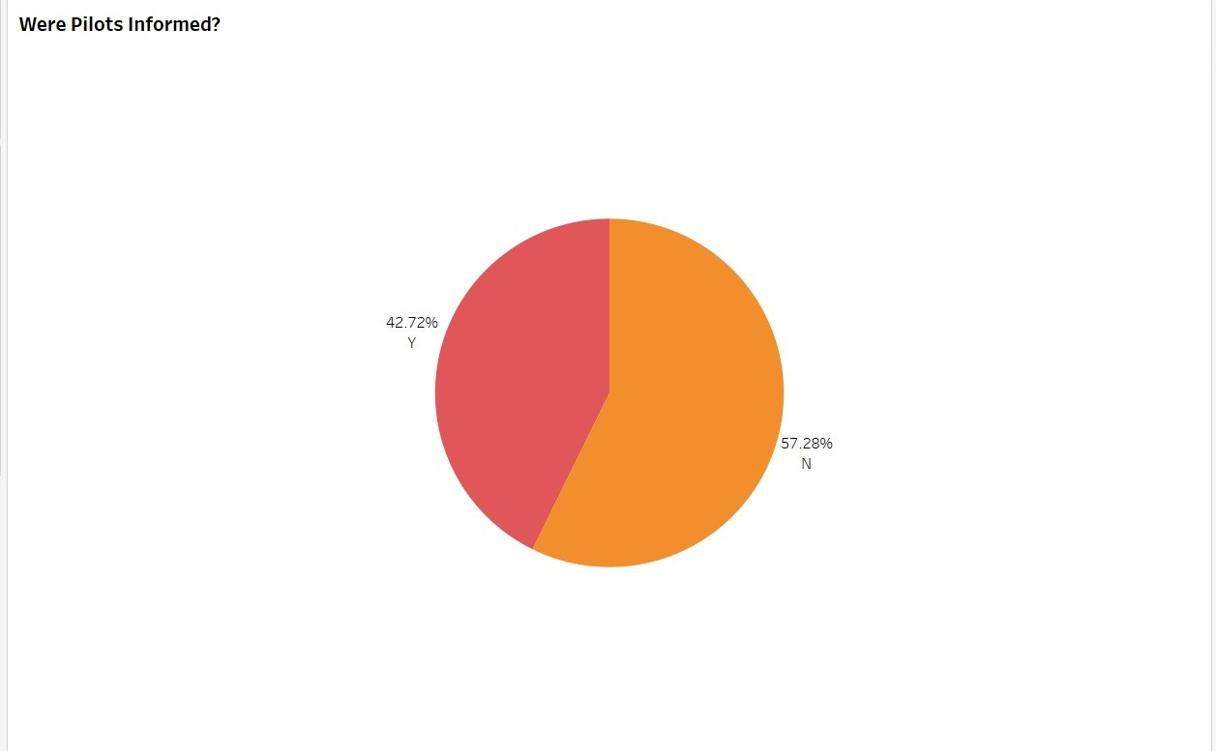

4.2. Impact on Flight

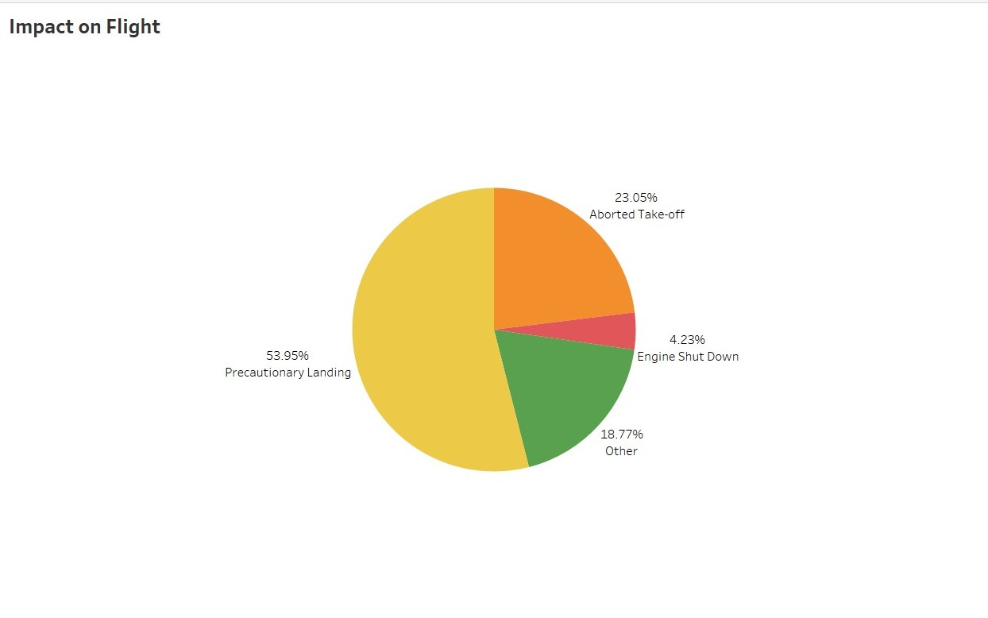

4.3. Prior Warning and Effect of Strike Relation

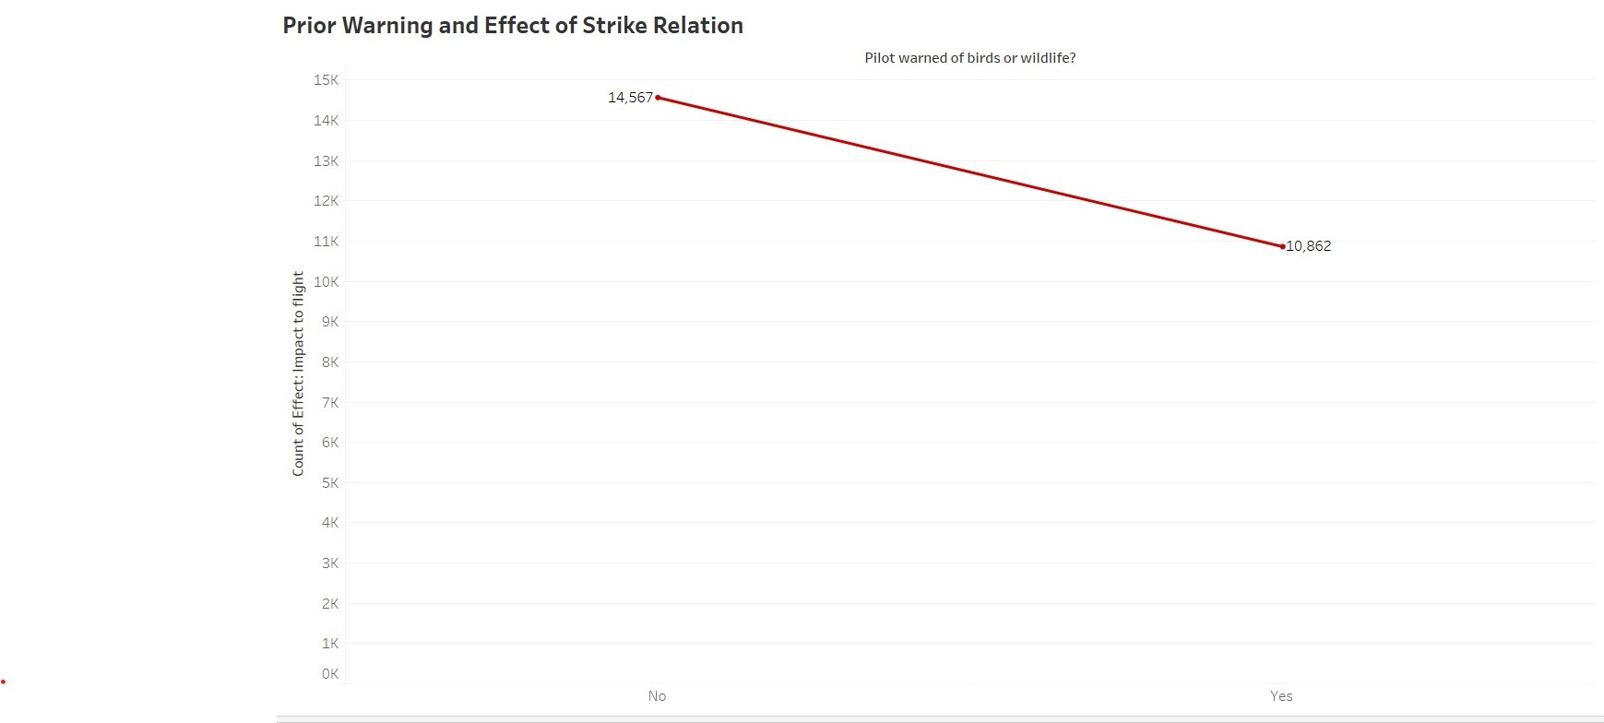

5. Birds Size

